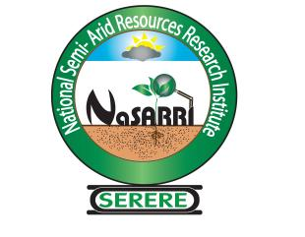
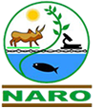

NATIONAL SEMI ARID RESOURCES RESEARCH INSTITUTE (NaSARRI) - SERERE

P.O. Box 56 Soroti - Uganda

Office: +256-454 463 665/463 663

LOOSE MINUTE

To: Director
17th/12/2024

Request for fuel deposit of 4,000,000
This is to request for fuel deposit of four million at Fahab petrol station in Serere to enable smooth running of the Institute as per the break down below;
Item | Cost (Ugx)
Generator | 2,000,000
Compound | 1,000,000
Administration | 1,000,000
Total | 4,000,000

Mugoya Joshua
SHRAO

