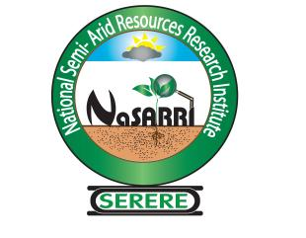
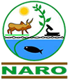

NATIONAL SEMI ARID RESOURCES RESEARCH INSTITUTE (NaSARRI) - SERERE

P.O. Box 56 Soroti - Uganda

Office: +256-454 463 665/463 663

To: (i) Inebu Irene
Senior Admin Assistant Gii
(ii) Olemukan Christine
Senior Admin Assistant Gi

17th/12/2024

From: Mugoya Joshua
SHRAO

Cc: Director
Cc: Senior Internal Auditor
Cc: Senior Accountant

INTERNAL MEMO
This is to draw your attention to the effect that for purposes of tracking, follow up, reporting on administrative and human function of the Institute, you are advised not to sign any official document in line with the above function unless delegated through consultation.

The purpose of this memo is also to inform Senior Internal Audit and Senior Accountant to follow the prescribed NARO procedures to creating order and consistency during day to day operations.

